User Manual of MutiSales Distribution System

Group 4

Yuqing Gu

Ziming Cui

Zeyao Yang

Complete date：10/27/2022

CONTENTS

1.Preface 3

1.1 Purpose 3

1.2 Software requirement 3

2.Functions introduction 3

2.1 Main Menu 3

2.2 Check Inventory and Trucks 4

2.3 Truck Arrangement 4

2.4 Set current order plan 4

2.5 Ship items 5

2.6 Clear form 6

2.7 Exit 6

3. Use process 6

3.1 Data’s entering 6

3.2 Get the arrangement 7

3.3 Exit the program 7

4. Precautions for use 7

4.1 Address 7

4.2 Inventory and truck data 7

5. Technical support 8

# 1.Preface

## 1.1 Purpose

This program aims in determining how to load the items that have to be shipped every day onto that day’s available trucks using data obtains from the EXCEL file *project.xlsx*.

The usage of the program has a high degree of freedom: the data can both get from the user and the excel file; the user can also reverse those data inside the program.

## 1.2 Software requirement

Jupyter Notebook (6.4.12 or higher)

# 2.Functions introduction

## 2.1 Main Menu

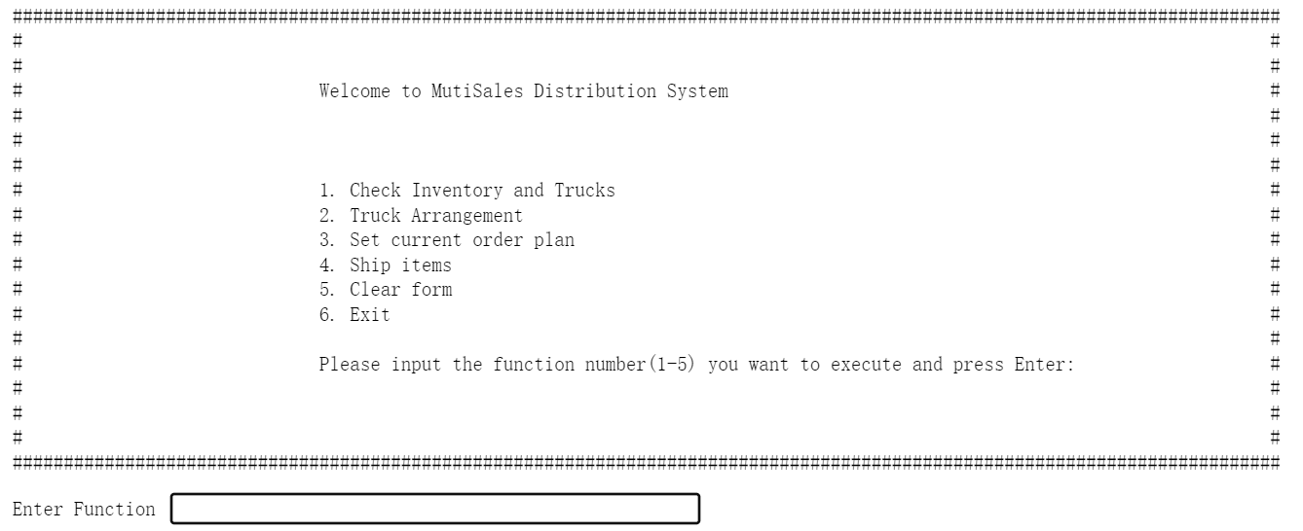

After run the program, the program will read and stored the data in the file *project.xlsx* in the main program, and then print this main menu.You can choose the function of the program you want to use by entering the number corresponding to the option.

Also, after finishing any step from 1 to 5, the program would return to the main menu for further operations.

## 2.2 Check Inventory and Trucks

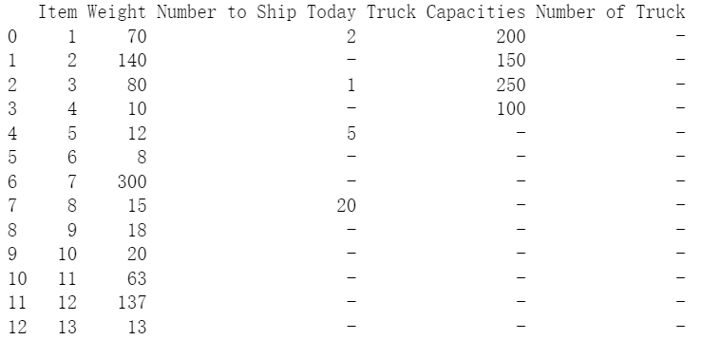

Enter 1 in the menu to view the list of inventories that need to be shipped and trucks available today that stored in the program now.

## 2.3 Truck Arrangement

Enter 2 in the menu to enter the truck arrangement manually.

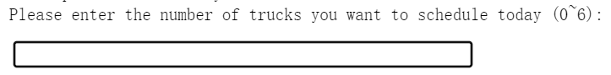

First, enter the total number of trucks;

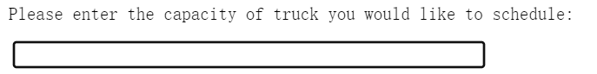

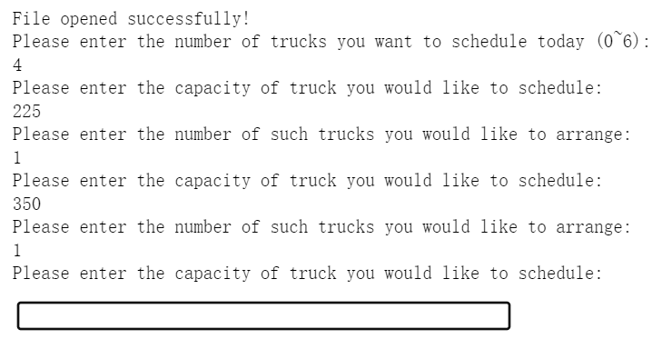

Then enter the capacities of available trucks with the number of that kind of truck in turns. When the number of trucks of different capacities equals the total number, press enter to go back to the main menu.

## 2.4 Set current order plan

Enter 3 in the menu to enter the shipping list manually. Follow the instruction to enter the item that needs to be loaded:

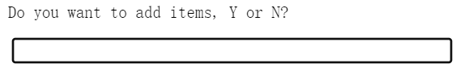

First, type Y to enter the item you want to add;

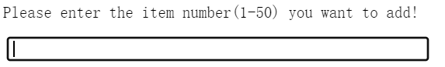

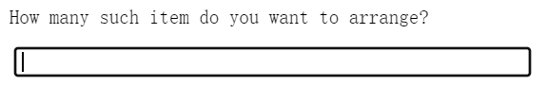

Then enter the item number with quantity of it in turns.

After finishing entering, type N when be asked whether you want to add items, and then press enter to go back to the main menu.

Make sure the form is cleaned before entering.

## 2.5 Ship items

This function would automatically compute how to arrange the items, and output the arrangement to the original file.

The output shows in this way:

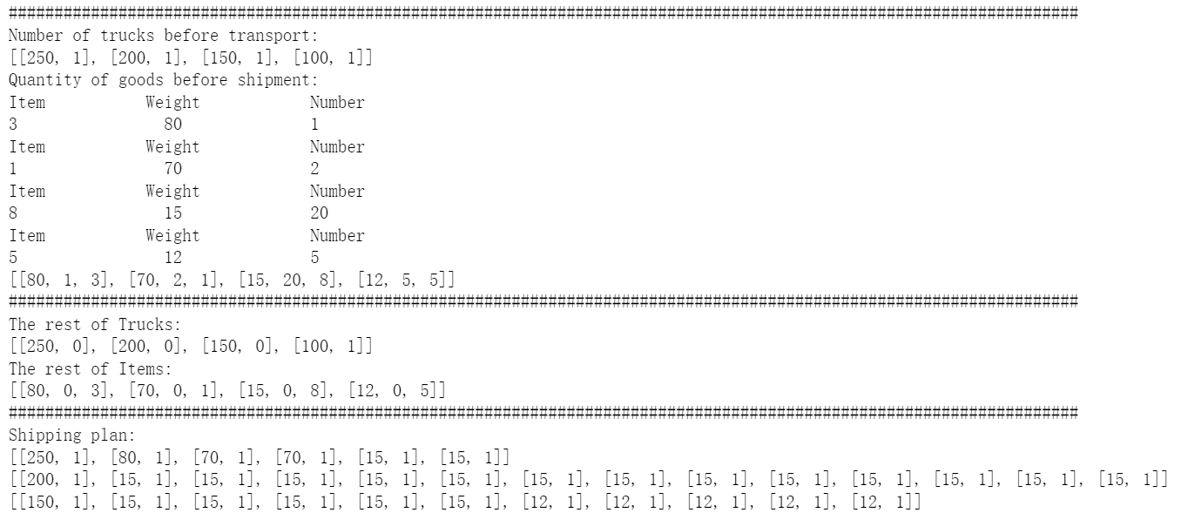

⑧

⑦

⑥

⑤

②

③

④

①

1. the list of available trucks. Inside one bracket of the list: the first number refers to the capacity of this kind of truck; the second number refers to the number of that kind of truck
2. item number
3. weight of that item
4. number of that item needed
5. the list of items that need to be shipped today
6. the list of the rest of the trucks. Inside one bracket of the list: the first number refers to the capacity of this kind of truck; the second number refers to the number of that kind of truck left
7. the list of the rest of the items. Inside one bracket of the list: the first number refers to the weight of this kind of item; the second number refers to the number of that kind of item left; the third number refers to the original number of that kind of item
8. the shipping plan, each row represents the loading of one truck. The first list inside one list shows the truck used, the rest of the lists show the item be loaded onto that truck, capacity/weight follows by the number.

## 2.6 Clear form

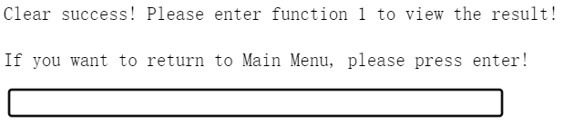

Enter 5 in the menu to clear the form that was used on the last day.

If you want to enter the inventory and trucks manually, you can use this function to clear the current form.

## 2.7 Exit

Enter 6 in the menu to exit the program.

# 3. Use process

## 3.1 Data’s entering

**3.1.1 Using excel**

1. Enter 1 to run the first order in the menu page, the program will print the inventories and trucks arrangement that day automatically and print them.



1. Press enter to go back to the main menu.
2. Enter 2 to use function *Truck Arrangement* to enter the number of trucks.

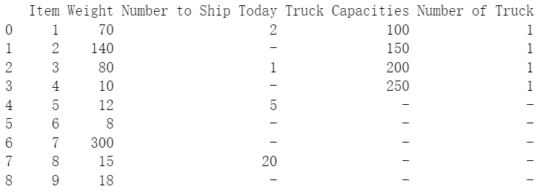

**3.1.2 Entering manually**

If the data cannot be gathered through an excel chart, please use the second and third command to enter the data manually:

1. Enter 5 in the main menu to clear the stored form.
2. Go bake to the main menu, and then enter 2 to run the *Truck Arrangement* function, enter the available trucks through the direction in 2.3.
3. Go bake to the main menu, and enter 3 to run the *Set current order plan* function*,* enter the item you need to ship today.
4. Go back to the main menu, enter 1 to see if the inventory and available truck are correct.

## 3.2 Get the arrangement

After check the inventory and truck list, enter 4 at the main menu to get the arrangement.

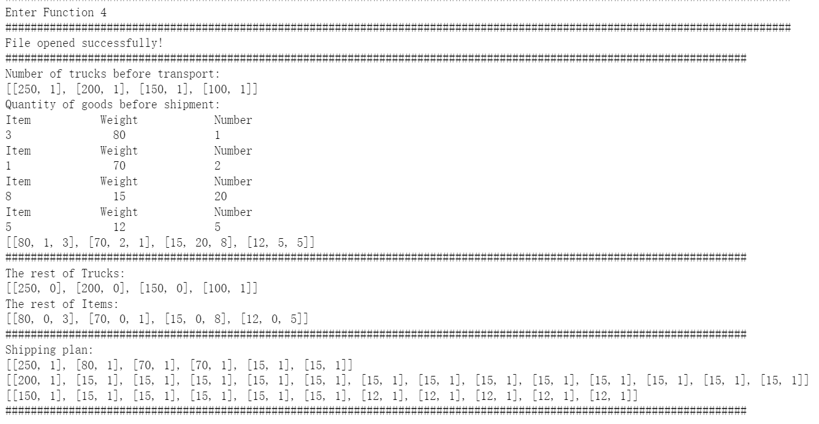

## 3.3 Exit the program

After getting the result and finishing the arrangement, press enter to go back to the main menu, and then enter 6 to exit the program. When you see “Exit System!”, you can close the whole program safely.

# 4. Precautions for use

## 4.1 Address

1. Please make sure the address of the file *project.xlsx* in the program is correct.
2. If is still report an error when the address is correct, use double slash after the address of disk.

## 4.2 Inventory and truck data

After run the program and get the main menu, the program has read and stored the data in the file *project.xlsx* in the main program. If manually input is needed, please run the function 5 *Clear form,* andmake sure the form has been cleared before entering data manually.

# 5. Technical support

Email: zxc701@case.edu